Monthly Expenses and Savings - Full Answer

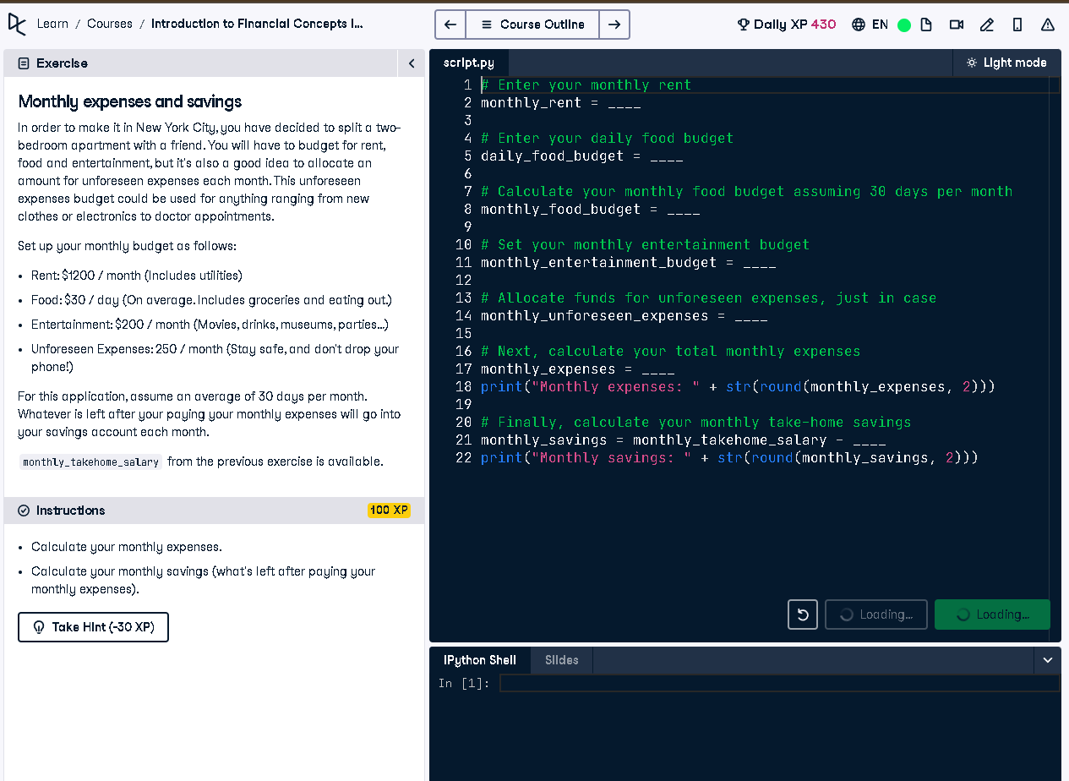

# Full Code Answer:

# Enter your monthly rent  
monthly_rent = 1200  
  
# Enter your daily food budget  
daily_food_budget = 30  
  
# Calculate your monthly food budget assuming 30 days per month  
monthly_food_budget = daily_food_budget * 30  
  
# Set your monthly entertainment budget  
monthly_entertainment_budget = 200  
  
# Allocate funds for unforeseen expenses, just in case  
monthly_unforeseen_expenses = 250  
  
# Next, calculate your total monthly expenses  
monthly_expenses = monthly_rent + monthly_food_budget + monthly_entertainment_budget + monthly_unforeseen_expenses  
print("Monthly expenses: " + str(round(monthly_expenses, 2)))  
  
# Finally, calculate your monthly take-home savings  
monthly_savings = monthly_takehome_salary - monthly_expenses  
print("Monthly savings: " + str(round(monthly_savings, 2)))

# Question:

How do you calculate monthly expenses and savings with fixed rent, food, entertainment, and unforeseen expenses budgets?

# 20-word Explanation (Question):

Monthly expenses consist of fixed and variable budgets like rent and food. Remaining income after these is your monthly savings.

# Answer:

Sum rent, food, entertainment, and unforeseen costs to get monthly expenses. Subtract from monthly_takehome_salary to get savings.

# 20-word Explanation (Answer):

Adding all expenses gives total monthly spending. Subtracting this from monthly salary reveals available savings for the month.